Participial Phrase as Head

🟩 What is Participial Phrase as Head?
# Source: AI Source: Provided by: [Data Path: Persons Table -> ID Column: 1, Name_En Column: Motasem Essam] -> From: [Chatgpt (GPT‑5 Mini)] on [8/7/2025]
A Participial Phrase is a phrase built around a participle, which is a verb form used as an adjective. In this type of phrase, the head is the participle (either present or past participle).

🔹 Structure of a Participial Phrase
# Source: AI Source: Provided by: [Data Path: Persons Table -> ID Column: 1, Name_En Column: Motasem Essam] -> From: [Chatgpt (GPT‑5 Mini)] on [8/7/2025]
[participle] + (optional object, modifiers, or complements)

- Present participle: verb + -ing → smiling, singing, running
- Past participle: usually ends in -ed, -en, or -t (regular or irregular) → baked, broken, lost

🔹 Function of the Head in a Participial Phrase
# Source: AI Source: Provided by: [Data Path: Persons Table -> ID Column: 1, Name_En Column: Motasem Essam] -> From: [Chatgpt (GPT‑5 Mini)] on [8/7/2025]
The participle (head) modifies a noun or pronoun, giving more information about it.

🔹 Examples by Participle Type
# Source: AI Source: Provided by: [Data Path: Persons Table -> ID Column: 1, Name_En Column: Motasem Essam] -> From: [Chatgpt (GPT‑5 Mini)] on [8/7/2025]
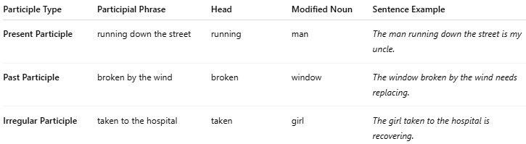
Participle Type | Participial Phrase | Head | Modified Noun | Sentence Example
Present Participle | running down the street | running | man | The man running down the street is my uncle.
Past Participle | broken by the wind | broken | window | The window broken by the wind needs replacing.
Irregular Participle | taken to the hospital | taken | girl | The girl taken to the hospital is recovering.

✅ Key Characteristics:
# Source: AI Source: Provided by: [Data Path: Persons Table -> ID Column: 1, Name_En Column: Motasem Essam] -> From: [Chatgpt (GPT‑5 Mini)] on [8/7/2025]
- The head of a participial phrase is always the participle.
- The whole phrase acts as an adjective.
- It must modify a noun or pronoun, often placed immediately next to it.
- Can occur:
  - Before the noun (the smiling girl)
  - After the noun (the girl smiling at me)

❗ Caution: Misplaced Modifiers
# Source: AI Source: Provided by: [Data Path: Persons Table -> ID Column: 1, Name_En Column: Motasem Essam] -> From: [Chatgpt (GPT‑5 Mini)] on [8/7/2025]
The phrase should be placed close to the noun it modifies to avoid confusion.
❌ Walking through the park, the birds were chirping.
✅ Walking through the park, I heard the birds chirping.

